Documentation for getting your VISIO Diagrams uploaded as Web pages to EAI Server
After having your component model or Flow Diagrams in Microsoft Visio as .vsd format, follow the below steps to get this published as webpage on EAI server.
Step 1:Save your Visio file in .vsd format to Save as type Web Page(* .htm,*.html) format to generate the required artifacts.
File > Save As >
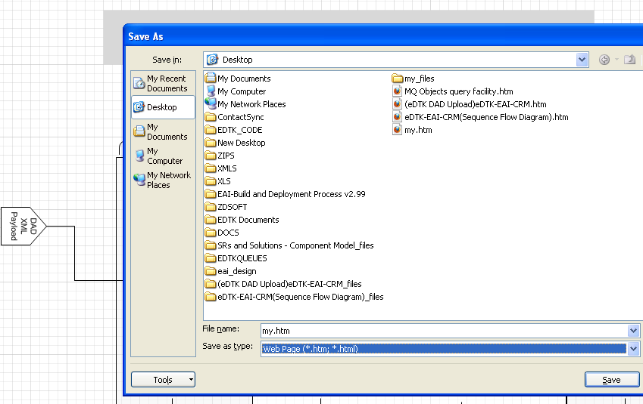
Artifacts generated are say,folder : my_files file: my_files.htm
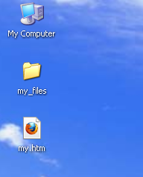
Step 2:Move the artifacts related to your component model diagram to server location under
/reuters/oraapp/as01/product/10.1.3.1/OracleAS_1/Apache/Apache/htdocs/eai_design
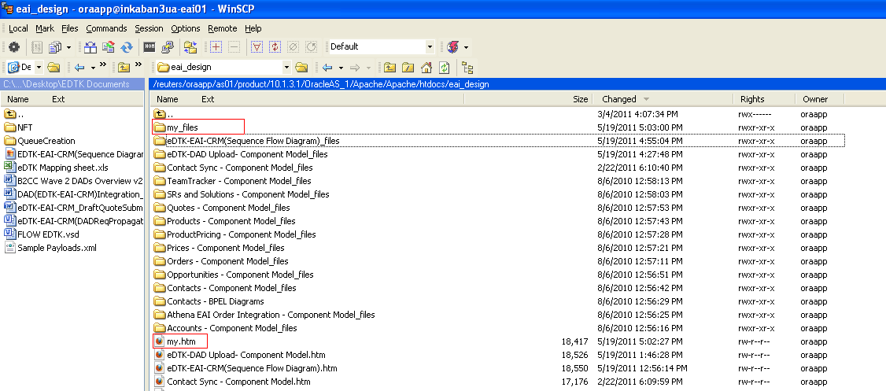

Step 2:Move the artifacts related to your component model diagram to server location under
Check for successful upload by putting the link in browser http://inkaban3ua-eai01:7777/eai_design/
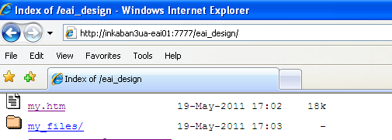
Issue: Opening the visio diagram link in browser : http://inkaban3ua-eai01:7777/eai_design/my.htm
- Pan and Zoom tab is Blank
- Prompt for Silverlight Plug-in
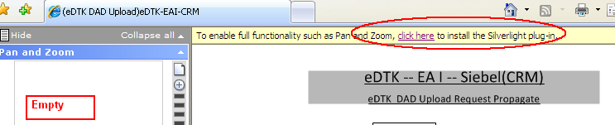

Cause:
By Default Output Format would be set as XAML that requires Silver light plug-in .
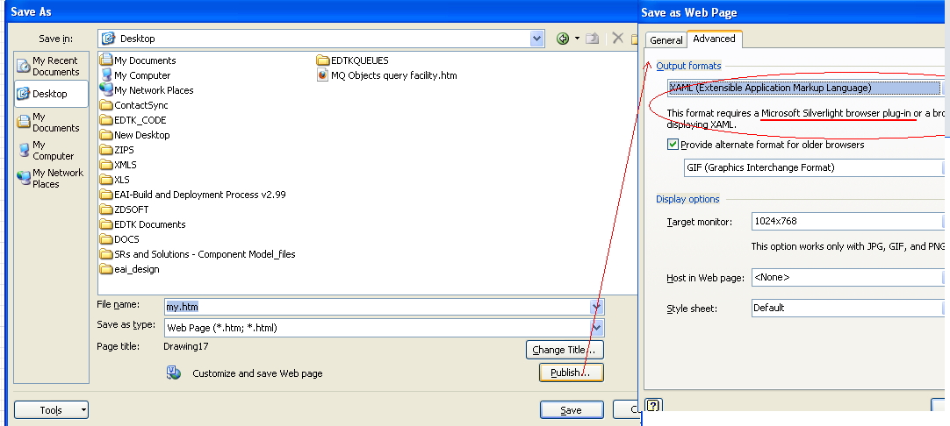
Alternate Settings to get things corrected:
Use Vector Markup Language and click the check box with “GIF” if needed.
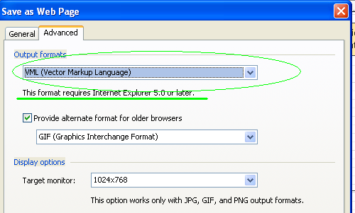
Zoom Tab looks better and works fine !!!
